O Valiant Hearts
Words by Sir John S. Arkwright Music by The Rev. C, Harris DD
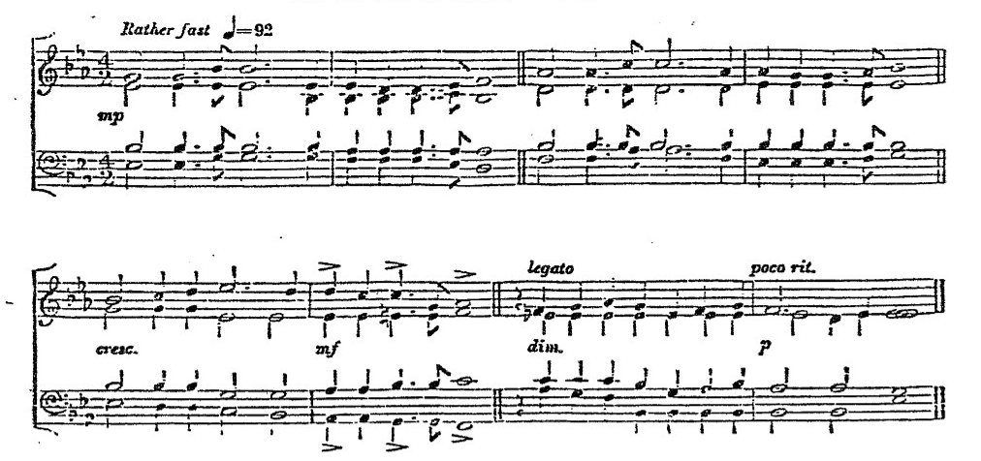
Tune: The Supreme Sacrifice

O valiant hearts who to your glory came
through dust of conflict and through battle flame;
tranquil you lie, your knightly virtue proved,
your memory hallowed in the land you loved.
Proudly you gathered, rank on rank, to war
as who had heard God's message from afar;
all you had hoped for, all you had, you gave,
to save mankind - yourselves you scorned to save.
Splendid you passed, the great surrender made;
into the light that nevermore shall fade;
deep your contentment in that blest abode,
who wait the last clear trumpet-call of God.
Long years ago, as earth lay dark and still,
rose a loud cry upon a lonely hill,
while in the frailty of our human clay,
Christ, our Redeemer, passed the self-same way.
Still stands his Cross from that dread hour to this,
like some bright star above the dark abyss;
still, through the veil, the Victor's pitying eyes
look down to bless our lesser Calvaries.
These were his servants, in his steps they trod,
following through death the martyred Son of God:
Victor, he rose; victorious too shall rise
they who have drunk his cup of sacrifice.
O risen Lord, O Shepherd of our dead,
whose cross has bought them and whose staff has led,
in glorious hope their proud and sorrowing land
commits her children to thy gracious hand.

